**Introduction To Asp.Net Mvc 5**

ASP.NET MVC is based on the MVC design pattern that allows you to develop software solutions.

ASP.NET is a free web framework for building websites and web applications on .NET Framework using HTML, CSS, and JavaScript.

ASP.NET MVC 5 is a web framework based on Model-View-Controller (MVC) architecture. Developers can build dynamic web applications using ASP.NET MVC framework that enables a clean separation of concerns, fast development, and TDD friendly

**MVC design pattern:**

* Allows you to develop Web application with loosely coupled components.
* Enables separating data access, business, and presentation logic from each other.

**1) Tight coupling**

ASP.NET Web forms are tightly coupled. Each .aspx page is dependent on it's code behind page which makes automated testing a nightmare.

**2) Loose coupling**

ASP.NET MVC is loosely coupled. The logic is separated into 3 parts.

* **MODEL**
  + Models are basically classes in C#.
  + Database operations such as fetch data or update data etc.
  + Represents information about a domain that can be the application data of a Web application.
* **VIEW**
  + End user gui (graphical user interface) which user can interact with system i-e html, css, bootstrap.
  + Represents the presentation logic to provide the data of the model.
* **CONTROLLER**
  + Controllers are classes in C#.
  + Contain logic and provide link between model and view.
  + Represents the logic responsible for coordination between the view and model classes.
  + Handles requests to the application by the user.
  + Get data from database.
  + Specify a view that returns a response to the client.

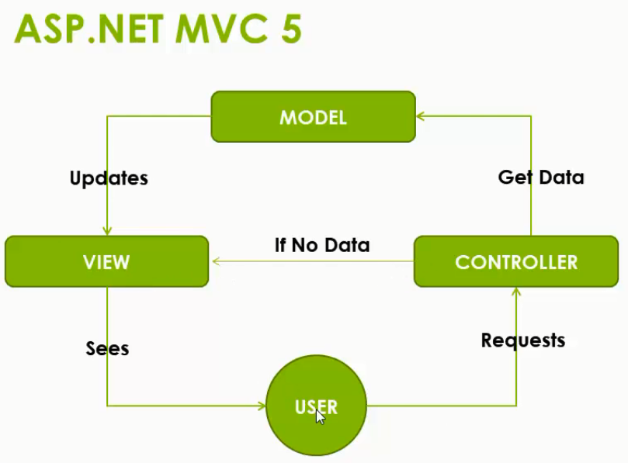

**As ASP.NET MVC is based on the MVC design pattern, it provides the following benefits:**

**Separation of concerns:** Enables you to ensure that various application concerns into different and independent software components.

**Simplified testing and maintenance:** Enables you to test each component independently. Thus, it allows you to ensure that it is working as per the requirement of the application and then, simplifies the process of testing, maintenance, and troubleshooting procedures.

**Extensibility:** Enables the model to include a set of independent components that you can easily modify or replace based on the application requirement.

**Pre-Requisites To Start With Asp.Net Mvc**

* C# programming language, HTML, CSS, JAVASCRIPT, BOOTSTRAP.
* .NET Framework 4.5 or later.
* Visual studio 2013 or later.
* We will use Visual Studio 2015.